Skinwalker Ranch Insiders Reporting Application

Requirements Document

|  |  |
| --- | --- |
| Revision | 0.3 |
| Review | pending |
| Author | Roger Altorfer |

Table of Contents

1 Problem Statement 4

1.1 PS-001 – Data Submission 4

1.2 PS-002 – Feedback 4

1.3 PS-003 – Inconsistency 4

1.4 PS-004 – Consolidation 4

1.5 PS-005 – Mapping of Anomalies and Activities 4

1.6 PS-006 – Reporting Dashboard 4

1.7 PS-007 – Process 5

1.8 PS-008 – Access Security 5

1.9 PS-009 – Data Security 5

2 User Stories 6

2.1 US001 – SWR Insider – New Event 6

2.2 US002 – SWR Insider Focus Admin – New Focus Activity 6

2.3 US003 – SWR Team – New planned Activity on the Ranch 6

2.4 US004 – SWR Insider - sign-up for Focus Event 6

2.5 US005 – Event L1 Review: L1 Reviewer 7

2.6 US006 – Event L2 Review: L2 Reviewer 7

2.7 US006 – Event Review: SWR Team 7

2.8 US007 – Dashboard functionality for SWR Insider 7

2.9 US008 – Dashboard functionality for SWR Team 8

2.10 US009 – SWR Insider Reporting 8

2.11 US010 – SWR Team Reporting 8

3 Events 9

3.1 UC001 - Submit New Event 9

3.1.1 Roles 9

3.1.2 Required Fields: Anomaly and Non-Anomaly 9

3.1.3 Required Fields: Poltergeist Contagion 10

3.2 Event Classifications 11

3.2.1 Main Classification Definition 11

3.2.2 Sub Classification Definition 11

3.3 Event Status 12

4 Process 13

4.1 PS001 – Event Review Process 13

4.2 PS001– L1 Review of submitted Events 14

4.2.1 Roles 14

4.2.2 Consolidate Events 14

4.2.3 Edit and reclassify Events 14

4.3 PS001– L2 Review of submitted Events 14

4.3.1 Roles 14

4.4 PS001– Review SWR Team of submitted Events 15

4.4.1 Roles 15

5 Activities 16

5.1 UC002 – New Activity: “Focus Group session” 16

5.1.1 Roles 16

5.1.2 Required Fields 16

5.2 UC003 – New Activity: SWR Team 17

5.2.1 Roles 17

5.2.2 Creation of a planned activity 17

5.2.3 Activity Classification 18

5.2.4 Activity Status 19

5.3 UC004 - Sign Up for Planned Activity: “Focus Group session” 19

5.3.1 Roles 19

5.4 UC005 – Mapping of Anomalies and Activities 19

5.5 UC006 – Like Event 20

5.6 UC007 – Comment Event 20

6 Reporting (tbd) 21

6.1 UC007 – Reporting SWR Insiders 21

6.2 UC008 – Reporting SWR Team 21

7 Roles 22

7.1 SWR Insider 22

7.2 Focus Admin 22

7.3 Review L1 22

7.4 Review L2 22

7.5 SWR Team 22

7.6 Adminstrator 22

8 Role Access Matrix 23

9 Data Model 24

# Problem Statement

## PS-001 – Data Submission

The current solution is a free-text spreadsheet which requires some experience to report event. This results not only in higher time consumption for the submission of the event, but also prevents the further usage of the submitted data.

## PS-002 – Feedback

The Spreadsheet does not allow us to close out individual cases and receive feedback directly from SWR team members as there is no real review process in place.

## PS-003 – Inconsistency

Event submission is not easy for new Members, all Fields are currently free-text which is time consuming. This results in inconsistent data and a high error rate on submission.

Due to data inconsistency with the current free-text fields, it is not possible to group, search, report on the submitted events.

## PS-004 – Consolidation

With the increasing Insider Group size, the same event might be submitted by several users at the same time with slightly different timestamps. Those events can’t be consolidated in the current solution. This results in duplicate entries and increases the review effort

## PS-005 – Mapping of Anomalies and Activities

Correlation of events with ongoing focus sessions, experiments or other activity on the ranch is not possible due to lack of data or reporting capabilities. Some of the data such as experiment information and other ranch activities must not be made public.

## PS-006 – Reporting Dashboard

Users and SWR Team have different requirements to review the data. Right now, there is no easy way to quickly check what happened in the last 24hrs, what is the status of the submitted event, where is review pending, what is closed etc.

## PS-007 – Process

The current solution does not offer a streamlined review process, this results in duplicate entries and false-positives. As reporting and mapping of events is key, we have to ensure the data quality in a review process with different roles.

## PS-008 – Access Security

The current solution does not prevent non-insiders from accessing and manipulating the data, there are no roles in place or any sort of security features to prevent users from manipulating data in the spreadsheet. All submitted Insider events must be available for Insiders to view. But other Data which could be beneficial for data analysis could contain sensitive information that must be kept secure from Insiders, such as camera location, planned experiments, etc.

## PS-009 – Data Security

Current spreadsheet can be downloaded, shared and expressed in many formats without consent or permission.

# User Stories

## US001 – SWR Insider – New Event

* As a SWR Insider, we want to be able to easily report anomalous findings and animals on the SWR webcam streams, but also adding an outage of the Livestream which could be the aftermath of a “Planned Activity” or other unfortunate events such as power outages. To have an easy submission experience, we would like to use predefined types and classifications to report an event in a fast an easy way.
* Besides the anomalies, we would like to submit an event for a Hitchhiker Events that happens such as strange dreams, electronic disturbances, etc.
* Once we create an event, we would like to see its progress and the findings of the reviewers.
* We would like to specially mark an Event with a like + that shows an important happening such as: UAP Landing, Dancing Orbs in the sky, UAP entering the Mesa, and this specially marked Event should be highlighted.

## US002 – SWR Insider Focus Admin – New Focus Activity

* For SWR Focus Admin, we would like to create a new Focus Group activity where Insiders can sign-up for. It should be possible for me to edit the focus activity prior to its occurrence and to see who will attend. Note: 2nd app
* During and after the Focus session, we need the capability to link the focus event with “Reported Anomalies” during that time period to identify potential correlations.

## US003 – SWR Team – New planned Activity on the Ranch

* As SWR Team member, we would like to add a planned activity to the database, such as maintenance work (HS2 renovation for example), experiments (antennae lesson on spectrum overlay for example) and anything to that effect for public disclosure.
* To identify correlations with reported Anomalies by Insiders we must be able to link a planned activity with one or many events during these set time periods.

## US004 – SWR Insider – Sign-up for Focus Event

* As SWR Insider, we need the overview of the upcoming focus sessions and need the ability to sign-up for.
* The Events we Signed up for should be shown on the “Insider Dashboard” as “My Activities” and a separate view for all planned Focus Events

## US005 – Event L1 Review: L1 Reviewer

* As a Reviewer, I need an Overview Dashboard that show me all submitted Anomalies that have been reported by the Insiders for review.
* I would need to consolidate “duplicate” Events that have been submitted by various users.
* I case I am not sure how to categorize the Event, we would like to forward it for review to the SWR Team, otherwise must have the means to close the Event

## US006 – Event L2 Review: L2 Reviewer

* As an L2 Reviewer, I need an Overview Dashboard that show me all forwarded Events from the L1 Review process to make an analysis of the unknown happening and link it to potential planned activities
* Once I have finished my work on the Event, I must be able to close it.

## US006 – Event Review: SWR Team

* As SWR Team, we need an Overview Dashboard that show us all forwarded Events from the L2 Reviewers to make an analysis of the unknown happening and link it to potential planned activities as well as forward it to official channels within SWR Ranch HQ for further analytics
* Once we have finished our work on the Event, we must be able to close it.

## US007 – Dashboard functionality for SWR Insider

As SWR Insider, we would like to have one single Dashboard that it capable to show me:

* Events submitted in the Last 24hrs (with filtering – custom) as default, but also the capability to see all submissions
* Upcoming Events like Focus Group Sessions I can sign up for
* Upcoming planned activities on the Ranch (I understand that the content of this activity might be unavailable to me.)
* Report functionality to show me all submitted SWR Insider Events that we can Filter and Download.

## US008 – Dashboard functionality for SWR Team

As a SWR Team member we would like to have a Dashboard that gives me the following capabilities:

* Amount of Events in the last 24hrs
* Planned Focus Group Events
* List of Events that require my review
* Upcoming planned activities and the capability to add a new activity

## US009 – SWR Insider Reporting

As an Insider, I would like to analyze all the submitted Events by my colleagues, but also see if there is a correlation of the Reported Events with any planned activity from the Focus Group or the SWR Team

## US010 – SWR Team Reporting

* As SWR Team Member, I would require the same basic reporting functionality given to the SWR Insiders.
* Although I would like to have more reporting capabilities that show the Reported Events on a Map. But also, the ability to see all submitted Events that happened during a planned activity.

# Events

## UC001 - Submit New Event

Creation of a new event with the following classification/sub-classification to select from.

After submission the Event must be handled according Process

### Roles

* SWR Insider
* SWR Team

### Required Fields: Anomaly and Non-Anomaly

|  |  |  |
| --- | --- | --- |
| Field Name | Value | Type |
| Activity ID | serial | display |
| Classification | foreign_key:event_classification | select |
| Sub Classification | foreign_key:event_sub_classification | select |
| Audio only | Boolean:no | checkbox |
| Start Time/Date | Time/Date | select |
| End Time/Date | Time/Date | select |
| Cameras* | foreign_keys:camerasmulti-select | Multi-select |
| Viewport | Foreign_key:viewport | select |
| Links | Text | Text(255) |
| Attachment | Foreign_keys:attachments | file |
| Description | Text | Text(1000) |
| Linked Anomalies | Foreign_keys:anomalies | lookup |
| Linked Activities | Foreign_key:activities | lookup |
| Activity_status_id | Plannedforeign_key:activity_status | Display(default:planned) |

* = mandatory

### Required Fields: Poltergeist Contagion

|  |  |  |
| --- | --- | --- |
| Field Name | Value | Type |
| Activity ID | serial | display |
| Classification | foreign_key:event_classification | select |
| Sub Classification | foreign_key:event_sub_classification | select |
| Audio only | Boolean:no | checkbox |
| Start Time/Date* | Time/Date | select |
| End Time/Date* | Time/Date | select |
| Location1 | text | select |
| Coordinates1 | LatLong | select |
| Link to Clip | Text | Text(255) |
| Attachments | Foreign_key:attachments | file |
| Description* | Text | Text(1000) |
| ActivityActivity status | Plannedforeign_key:activity_status | display (default:planned) |

1 = Can be hidden or changed to a radius for security reasons (tbd)

* = mandatory

## Event Classifications

### Main Classification Definition

|  |  |
| --- | --- |
| Classification | Description |
| Anomaly | An observed event which lacks conventional explanation |
| Non-Anomaly | An observed event which is easily identifiable |
| Poltergeist Contagion | An observed event which coincides with a personal experience or oddity |
| Other | An observed event which does not fit any category |

### Sub Classification Definition

|  |  |  |
| --- | --- | --- |
| Classification | Sub-Classification | Description |
| Anomaly | UAP | Unidentified Aerial Phenomenon |
|  | UFO | Unidentified Flying Object |
|  | Glitch | Camera glitch, timestamp jitters, etc. |
|  | Other | An anomaly which does not fit any category |
|  |  |  |
| Non-Anomaly | Animal | Easily identifiable insect or animal |
|  | Human | Easily identifiable humans, one or multiple, human-made causes |
|  | Weather | Easily identifiable weather phenomenon or pattern |
|  | Other | A non-anomaly which does not fit any category |
|  |  |  |
| Poltergeist Contagion | Hitchhiker | Paranormal phenomenon which may attach its self to investigators |
|  | Electronic Hitchhiker | Electronic and paranormal phenomenon which may affect electronic devices |
|  | Compromised Cognition | An event in which a person may experience inhibited cognition without obvious causation |
|  | Illness | An event in which a person may experience sudden and/or unexplainable illness |
|  | Nightmare | A nightmare or night terror which coincides with a relevant observed event |
|  | Other | A contagion which does not fit any category |

## Event Status

The following status must be updated according to the Review Process

|  |  |
| --- | --- |
| Name | Description |
| Submitted | User submits the Event for L1 review |
| L1 Review | L1 review in progress |
| Submitted L2 | L1 submits the Event for L2 review |
| L2 Review | L2 review in progress |
| Submitted SWR | L2 submits the Event for SWR review |
| SWR Review | SWR review in progress |
| Closed | End state |
| Deleted | Event will not show up in any report or link |

# Process

## PS001 – Event Review Process

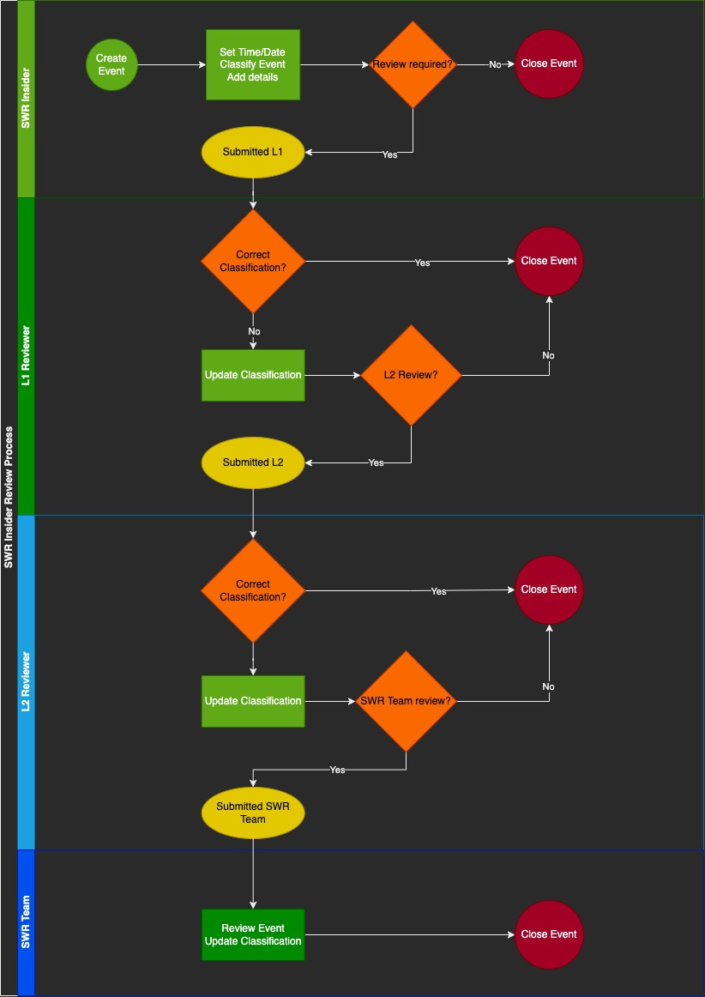

## PS001– L1 Review of submitted Events

* The L1 Reviewer must see all new submitted events which are pending for review on the Dashboard (Status: “Submitted L2”).
* Once a L1 reviewer opens a submitted event, the event status must be updated to “L1 Review” and must no longer be editable by the submitter.

### Roles

* L1 Reviewer

### Consolidate Events

* Events that occurred at the same Time must be shown grouped on the dashboard for easier reviewing, grouping must be based on Time of occurrence and Camera.

### Edit and reclassify Events

* Reviewer must be able to edit all select Fields of the Event to make a reclassification if required.
* Reviewer must Close the Event if everything is correct identified, if not, he must forward the Event to L2 Review for further Investigation.

## PS001– L2 Review of submitted Events

* The L2 Reviewer must see all new submitted events which are pending for review on the Dashboard (Status: “Submitted L2”).
* Once a L1 reviewer opens a submitted event, the event status must be updated to “L2 Review” and must no longer be editable by the submitter.

### Roles

* L2 Reviewer

#### Consolidate Events

Events that occurred at the same Time must be shown grouped on the dashboard for easier reviewing, grouping must be based on Time of occurrence and Camera.

#### Edit and reclassify Events

* Reviewer must be able to edit all select Fields of the Event to make a reclassification if required.
* Reviewer must Close the Event if everything is correct identified, if not, he must forward the Event to SWR Review for further Investigation.

## PS001– Review SWR Team of submitted Events

The SWR Team must see all new submitted events which are pending for “SWR review” on the Dashboard.

Once a “SWR Team” member opens a submitted event, the activity status must be updated to “SWR review” and must no longer be editable by any other Role.

### Roles

* SWR Team

# Activities

## UC002 – New Activity: “Focus Group session”

Creation of an upcoming Focus Group event where SWR Insiders and/or SWR Team can sign up for. The activity must be editable for the Focus Admin until it will be automatically closed (x-hours) 3 days after the last update, earliest 72hrs after planned_end and last update.

### Roles

* Focus Admin
* SWR Team

### Required Fields

|  |  |  |
| --- | --- | --- |
| Field Name | Value | Type |
| Activity ID | serial | display |
| Classification | Foreign_key:activity_classification | Display: Focus Session |
| Sub Classification | Time/Date | select |
| Start Time/Date* | Time/Date | select |
| End Time/Date* | Foreign_key:camerasmulti-select | Multi-select |
| Cameras* | Foreign_key:viewport | select |
| Description | Text Field (optional) | Text(255) |
| Activity status | foreign_key:activity_status | Select (default:Planned) |

* = mandatory

1 = Locked from change

## UC003 – New Activity: SWR Team

### Roles

SWR Team

### Creation of a planned activity

Creation of a planned ranch activity to track potential correlation with Insider reported events. With the capability to hide the Event from other Roles (except Administrator).

#### Required Fields

|  |  |  |
| --- | --- | --- |
| Field Name | Value | Type |
| Activity ID | serial | display |
| Classification | foreign_key:activity_classification | select |
| Sub Classification | foreign_key:activity_sub_classification | select |
| Confidential | Boolean:yes | checkbox |
| Start Time/Date* | Time/Date | select |
| End Time/Date* | Time/Date | select |
| Cameras | foreign_key:camerasmulti-select | Multi-select |
| Title | Text | Text(50) |
| Description | Text | Text(1000) |
| Attachments | Foreign_key:attachments | file |
| Linked Anomalies | Foreign_keys:anomalies | select |
| Linked Activities | Foreign_keys:activities | select |
| Activity status | Plannedforeign_key:activity_status | select (default:planned) |

* = mandatory

### Activity Classification

|  |  |  |
| --- | --- | --- |
| Classification | Sub Classification | Description |
| MaintenanceClassification | Drillingselect |  |
| Sub Classification | Digging |  |
|  | Other |  |
| Experiment | Drilling |  |
|  | Digging |  |
|  | Rockets |  |
|  | Energymulti-select |  |
|  | Spiritual |  |
|  | Other |  |
| VisitorActivity | (blank)Planned |  |
| Other | (blank) |  |
| Focus Session | (blank) |  |

### Activity Status

* Planned (default), can be edited by Focus Admin, SWR Team
* Closed
  + (auto-close x-days after last update, not earlier than x-days after planned end-date) except manually closed.
  + Locked from editing when closed
  + Can be re-opened by SWR Team or Administrator for editing.

## UC004 - Sign Up for Planned Activity: “Focus Group session”

Upcoming Focus Group events must be visible to all Roles to sign up for from the Dashboard (Upcoming Activity). Once signed-up, it must be visible on the Dashboard “My Activities” (My Upcoming Activities).

It must be possible to open the activity from the Dashboard to see the Details and to remove my attendance.

### Roles

* SWR Insider

#### Consolidate Events

Events that occurred at the same Time must be shown grouped on the dashboard for easier reviewing, grouping must be based on Time of occurrence and Cameras.

#### Edit and reclassify Events

Reviewer must be able to edit all select Fields of the Event to make a reclassification if required.

Reviewer must Close the Event if everything is correct identified. Otherwise it will be marked as closed 72 hours after last update.

## UC005 – Mapping of Anomalies and Activities

A All running or closed Activities must automatically be linked to reported Anomalies during the Start and End Time.

SWR Team Members can review the linked events and add additional anomalies that happened after the End Time. The status must automatically be updated to closed 7 days after the last update.

## UC006 – Like Event

Users must be able to “Like” an Event or Activity to be shown on the Dashboard as “Event Leaderboard”

## UC007 – Comment Event

Insiders must be able to add/modify/delete comments to events, this applies to all of status =!deleted

# Reporting (tbd)

## UC007 – Reporting SWR Insiders

tbd

## UC008 – Reporting SWR Team

Tbd

# Roles

## SWR Insider

Standard Role given to all active SWR Insiders

Confidential” Activities MUST be hidden

## Focus Admin

Assigned by SWR Team or Administrator

Role to Create a New Activity of Classification “Focus Session”

Capability to modify the event until: Status “Closed”

Confidential” Activities MUST be hidden

## Review L1

Access to Open and Edit Events of Status “submitted”

Capability to submit Event to L2 Review

Can close Event

Confidential” Activities MUST be hidden

## Review L2

Access to Open and Edit Events of Status “submitted”

Capability to submit Event to SWR Team

Can close Event

Confidential” Activities MUST be hidden

## SWR Team

Access to SWR Team Reports

Access to all Data

Can Create/Manage/View Activities and Anomalies not in status “closed”

Can re-open all closed Activities and Anomalies

Enhanced reporting capabilities with Camera Location Information

## Adminstrator

Really?

# Role Access Matrix

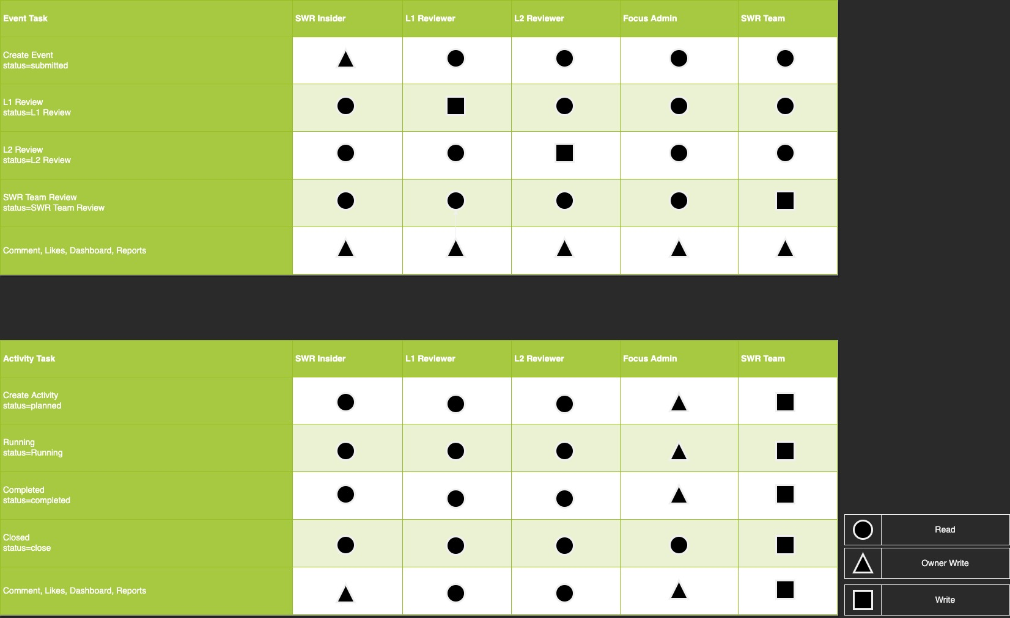

# Data Model